2022 Spring newsletter 5-1-2022

Kelsey Arboretum
18 Kelsey Road, Boxford, MA 01921
“Harlan P Kelsey, descendant of William Kelsey, a 1st settler of Cambridge MA, 1632"

SPRING BLOSSOM DAY - Saturday - May 21, 2022
(rain date Sun. 5/22/2022)
1-4 pm
18 Kelsey Rd, Boxford MA
Tour Docent: Tom Falzarino
Plan to attend and tour with Tom Falzarino as he speaks about the plants, Harlan Kelsey and why he developed the Kelsey Highlands Nursery in Boxford, MA..

Some Kelsey Highlands Nursery History
The Kelsey Arboretum features the beautiful native shrubs and trees that Harlan P. Kelsey grew up with in his boyhood home in Highlands, North Carolina. His father, Samuel T Kelsey, a city planner, along with his partner Clinton C. Hutchinson, founded the city of Highlands, NC, nestled high in the Smoky Mountains. Surrounded by beautiful Carolina hemlocks, native rhododendrons, azaleas, and mountain laurels, young Harlan developed a nursery business in Highlands NC in the late 1800’s. As his business and notoriety grew, he moved his office to Boston MA and searched for suitable land to develop a New England based nursery. His search ended in 1912 in Boxford MA, where he developed Kelsey Highlands Nursery on 500 acres of previous farmland. His structured fields, greenhouses and testing grounds were filled with plantings sourced from Highlands NC and the Smoky Mts. His original business, sales and transport services were at the corner of Ipswich and Georgetown Roads. In 1929, Harlan moved his Boston office to his new office and landscape design studio in the rebuilt Barnes barn at 18 Kelsey Rd. With fields located adjacent to the Boston & Maine Railroad on Depot Rd, transporting nursery products outside of local areas expanded the business even more. Upon buying Cadet Campground in the early 1930’s, Harlan converted the land to an airport runway to accommodate his time-constrained clients who wanted to fly in, pick out specimens and fly out within hours.
What remains of Kelsey’s 500 acre Highlands Nursery is today’s Kelsey Arboretum, which includes Harlan’s last home and landscape design office. After his death in 1958, son Seth Kelsey, also a renowned landscape designer and horticulturist, managed the nursery business until it was sold off to create new neighborhoods. Many of the nursery’s plantings are still seen in areas between Georgetown & Ipswich Rds., Carolina Way, Hemlock and Kelsey Rds.

What is a Rhododendron?
They say, “a rose is a rose is a rose”, are rhododendrons the same? Not exactly. The Latin name “rhododendron” comes from two Greek words: rhodon meaning rose, and dendron meaning tree. The biological plant family name is Ericacease. Although rhododendron species are similar, the careful eye notes differences in size and shape of the leaves, blooms have 5-7 petals, some petals rounded, some pointed, some with delicate ruffles, some with touches of white or yellow in the center or no alternate center color or markings, some have 5, 7 or 10 stamens and some are sweet smelling. As you enjpy the blooms, be sure to read the Name Plates identifying each species..

Open invitation to visit the Arboretum
Although the deer gate and fence may look imposing, the Public is always welcomed during the day, dawn to dusk. We ask the public to open and CLOSE the gates when both entering and leaving the Arboretum, because while People are Welcomed, DEER ARE NOT WELCOMED. Dogs on a leash are also welcomed and our picnic area and benches offer peaceful respites.

Spring maintenance activities
Spring has bustled with activity around the Arboretum. In addition to normal spring clean-up, raking and checking specimens for damage, special volunteers get kudos for some very needed work.
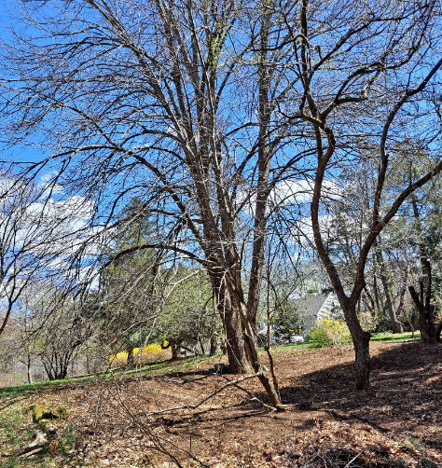
Sav-A-Tree, for Earth Day, donated a morning of pruning and removing dead branches and trees in the Meadow Area to optimize the beauty of our large beautiful Linden tree, Cork trees, Sargent Cherry and Crabapple trees gracing the Meadow. A much appreciated thank you for their work.
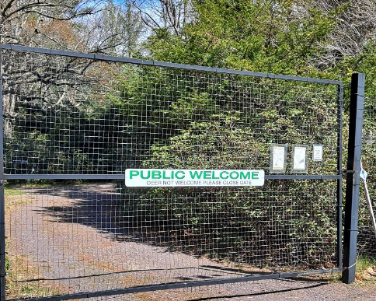
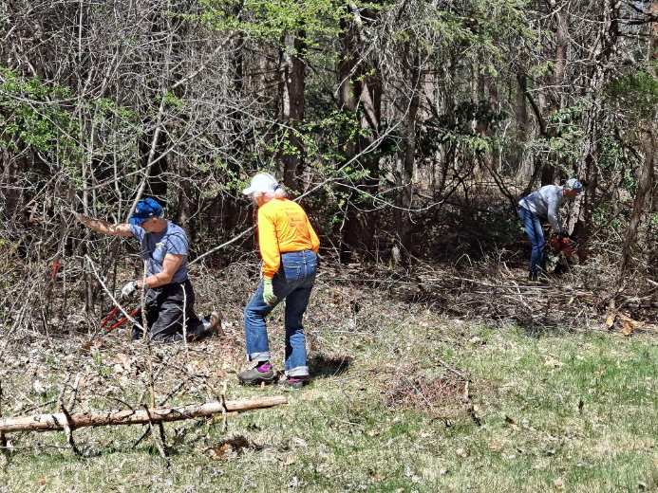
Volunteers Tony and Dave and their trusty power saws and tools worked on the other side of the Meadow Area to cut and remove the large dead spruce tree that had fallen, as well as clearing out smaller dead trees, brush and pruning branches to expose the Holly row, the Bayberry bush, the Yellowwood tree row and the Colorado Spruce row. Although this is a work in progress, HSB is thankful for every minute they have donated to make the Meadow Area more meaningful to visit.
The Arboretum’s new sign on the main front gate and on the back trail gate was donated by local Graphic Designer, Terrance M. Brown. HSB has struggled with comments from potential visitors about how the gate is always closed and therefore assumed the Arboretum to be closed. HSB is extremely thankful for this new sign and hopeful it presents a “Welcome” invitation to potential visitors.
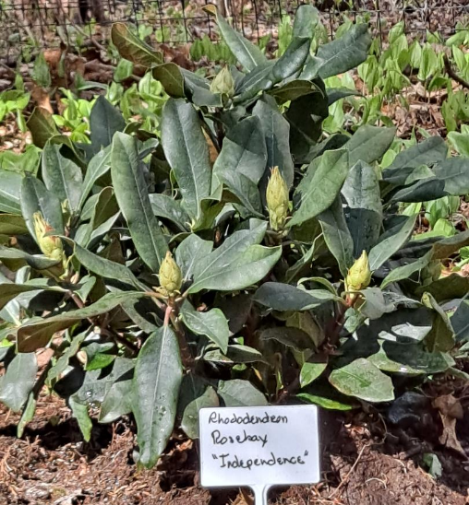
A new Rhododendron Maximum “Independence” (aka. Rosebay Independence) has been planted in the picnic area as a thank you gift for all the work and support Sally Wood has and continues to give to the Kelsey Arboretum. Our original “Independence” is located on the center circle path, please stop by this specimen for the history of this special July 4th blooming rhododendron.
Nesting Turkey
The Arboretum has a nesting turkey and a diligent male turkey guarding her. Please be considerate as you walk the main path near the Hornbeam tree that intersects with the garden bench path; and do not be surprised to see the male fly into the trees above her.
Deer Fence Repairs Funding
Several of the Arboretum’s smaller Carolina Hemlocks and Canadian Yews and broadleaf evergreens in the glade area were damaged this winter by deer entering via a variety of sources. We have fertilized these to encourage regrowth but, to help curtail this problem, the Arboretum would like to repair the deer fence along the perimeter trail leading to the rail trail. We encourage your tax-deductible donations and memberships to help us in this endeavor.

