Limited Project Narrative

Access Driveway to future Boxford Department of Public Works Facility

Boxford, Massachusetts

Prepared for: Town of Boxford
7 Spofford Road
Boxford, MA 01921


Prepared by: TEC, Inc.
282 Merrimack Street
2nd Floor
Lawrence MA, 01843

April 24, 2023
Limited Project Narrative
April 24, 2023

Name of Owner: Town of Boxford
Name of Facility: DPW Access Driveway
Location: 7 Spofford Road, Boxford MA

This narrative summarizes the qualifications for the above mentioned submittal as a “limited project” under Section 10.53-(3) of the Wetland Protection Act. Section 10.53 – (3) states in part:

“In determining whether to exercise its discretion to approve the limited projects listed, the Issuing Authority shall consider the following factors: The magnitude of alteration and the significance of the project site to the interests identified in MGL c. 131, S. 40, the availability of reasonable alternatives to the proposed activity, the extent to which adverse impacts are minimized, and the extent to which mitigation measures, including replication or restoration are provided to the protection of the interests identified in MGL c. 131 s. 40.”

Further, Section (e) of states in part:

“The applicant shall design the driveway according to the minimum length and width acceptable to the Planning Board, and shall present reasonable alternatives means of access to the Board. The applicant shall provide replication of bordering vegetated wetlands to the extent practicable.”

Magnitude of the Alteration
There is no alteration/filling of BVW or floodplain. The impacts of this proposed driveway are limited to the buffer zone. The total impact of the project within the buffer zone is approximately 1,600s.f. however much of that area is being improved for stormwater runoff attenuation and water quality improvements. The proposed paved area within the buffer zone is approximately 350s.f. The majority of this area is completely over grown with Japanese Knotweed.

Width of the Driveway
Although the driveway will not see large volumes of traffic counts, the vehicles and equipment that the driveway will serve necessitates the proposed width. Vehicles such as Loaders, backhoes, dump trucks, etc. have larger widths and wider turning radii than passenger vehicles. This is particularly important during the winter months when two large sanding trucks with the side wing plows attached are trying to pass each other. This was concurred by the planning board on April 19th. A copy of those minutes is attached.

Alternatives Analysis
Four alternatives for the roadway location were considered along with 4 alternatives for the roadway width. The following is a summary of each alternative considered for the design and a brief analysis of how it would impact the site:

Alternative 1 – No Build

The No Build alternative would leave the existing access road unchanged from its current configuration. Current roadway widths through this corridor range from 14 to 17 ft. which will not support safe 2-way traffic. The detrimental impact of a vehicle breakdown or malfunction cannot be overstated. A mechanical breakdown during a winter storm event would severely impede the DPW’s capacity to maintain the roadway network for the town in safe and reasonable manner. The image below depicts the existing route of the roadway.

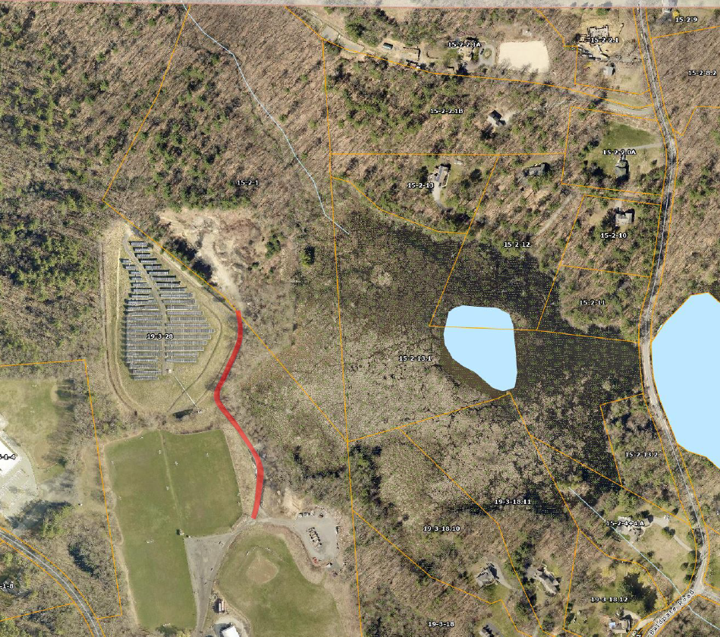

Alternative 2 – Access from Baldpate Road

Alternative 2 seeks to find an alternate connection location and proposes access via Baldpate Road to the east, as can be seen in the map below. Baldpate Road is the only reasonable alternative to access via the existing facility but presents several challenges including: crossing an existing body of water, much more extensive impacts to resource areas, a large amount of tree removal, and the fact that Baldpate Road is only 20 ft. wide at the connection location presents the same challenges described above.

Alternative 2 would have the largest environmental impact of all the options while placing truck traffic directly onto Baldpate Road which is unsuitable for a commercial entrance and associated truck traffic.

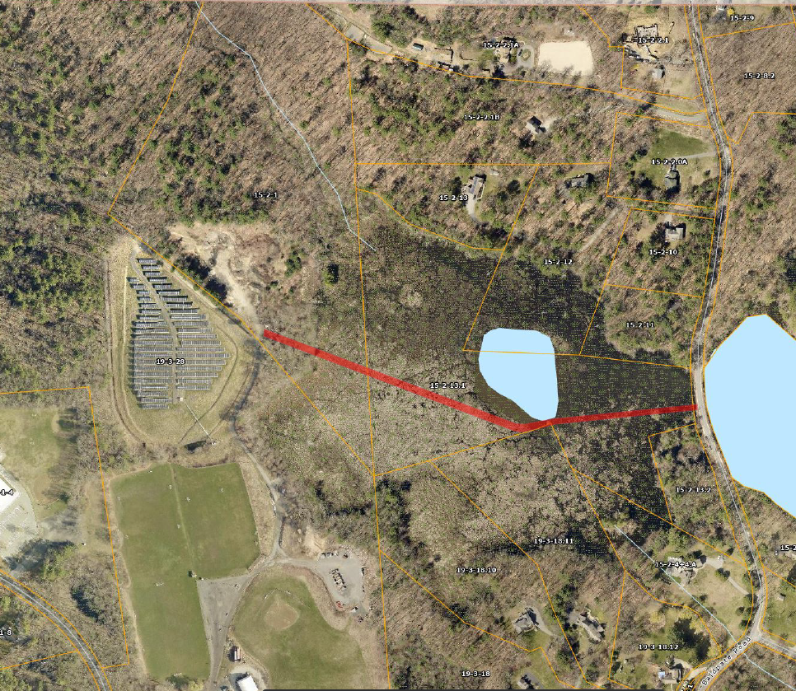

Alternative 3 – Access through the Landfill Area

Alternative 3 seeks to avoid any impacts to the neighboring resource area and moves the access road up the slope of the landfill and recreation area as can be seen in the below image. While this alternative would not infringe on any undisturbed resource areas, it would have several impacts on the existing site including a loss of a portion of an existing soccer facility and construction on top of the cap of a closed landfill make it a near impossibility. The driveway area adjacent to the solar field infringes on a swale which mitigates the runoff from the solar field. In addition to the permanent site impacts, this alternative also introduces the added difficulty of construction on steep slopes directly adjacent to a power transmission facility. The difficulty of construction and impacts to existing stormwater BMPs make Alternative 3 a considerably more complicated and near impossibility to construct. This also combined with the loss of a full-size soccer field and access to the landfill liner system make this alternative less desirable for the Town.

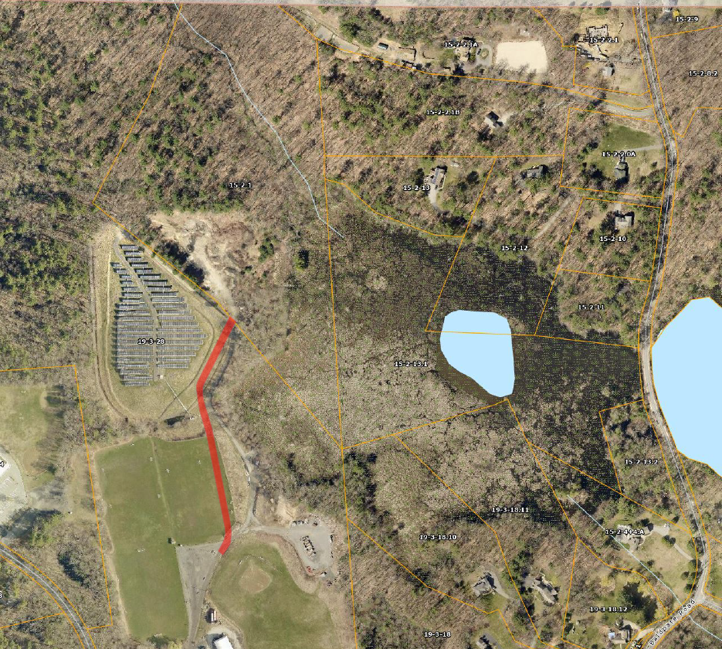

Alternative 4 – Rehabilitation of the Existing Access Drive (Preferred Alternative)

Alternative 4 proposes to use the existing location of the access drive while widening it to support two-way traffic of DPW vehicles and equipment as can be seen from the image below. Building on top of the already existing road would cut back on soil excavation costs and would not infringe on abutting properties or other land uses. This alternative will result in minimal impacts to the resource buffer but will maintain all existing site uses. Further, the reconstruction of the driveway would allow for the installation of a water quality swale and the paved surface would replace the gravel driveway that currently erodes during periods of high precipitation.

Alternative 4 balances improving the existing roadway to a width approved by the Planning Board, while minimizing resource area impacts and in fact improving runoff quality and quantity, which make it the preferred alternative for the Town. The width of the proposed roadway will determine the extent of the impact which will be discussed in the remainder of this analysis.

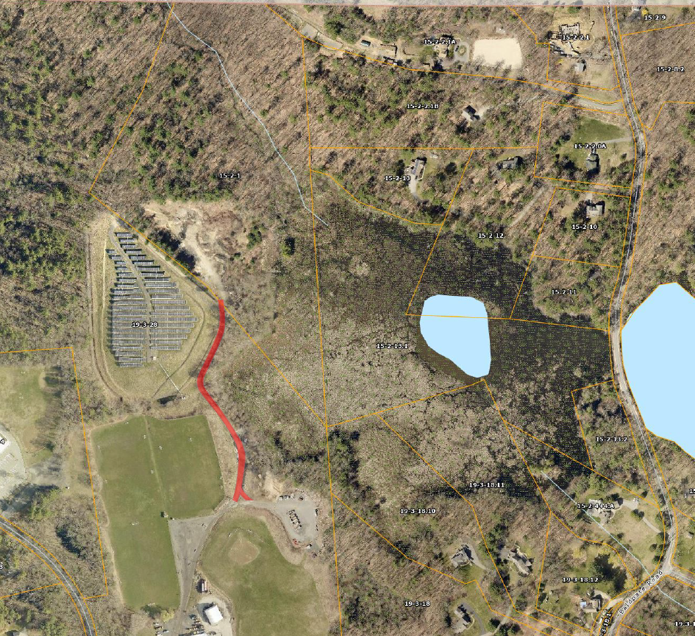

Proposed Mitigation/Replication
As previously stated, there is no resource area filling which would require wetland replication. However, the proposed plan does incorporate significant stormwater mitigation improvements. Both peak attenuation and stormwater quality will be improved under the proposed conditions. The current gravel driveway is used primarily by the DPW and solar company for maintenance. Periodically, during heavy rains the gravel driveway will washout or erode in areas sending material directly into the adjacent wetlands. There is no peak attenuation or treatment of stormwater before entering the wetland area. The proposed plan incorporates a stormwater quality swale and minor stormwater detention basin to attenuate peak flows and improve stormwater quality prior to discharge. Further, the current buffer zone is predominantly dominated by the invasive species, Japanese Knotweed. As can be seen in the picture below, the area adjacent the gravel road will be improved, the invasive species removed and appropriate stormwater BMPs installed. This is a major improved over the current conditions for the adjacent resource areas.

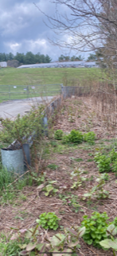
1. Buffer Area

Conclusion
Based on the facts that the extent of the disturbance is limited to a small area of the buffer zone and no wetlands, the width and length of the driveway was approved by the Planning Board, the alternatives analysis demonstrates no reasonable alternative, and the mitigation of the disturbance improves runoff peak attenuation and water quality, the Commission has the discretion to approve this access driveway as proposed under the “limited project” designation.

