May 31, 2018

Conservation Commission
Attn: Ross Povenmire
7A Spofford Road
Boxford, MA 01921

Subject: Seeking approval for Pine Tree Removal

Good evening. My name is Matt Rainville and I reside at 57A Deer Run Road in Boxford, MA. The intent of this letter is to obtain approval to professionally remove 7 trees that pose a safety risk/ hazard to my family. 4 of the 7 trees reside within 100 ft of the conservation land on my property. These trees have been evaluated and deemed high risk of falling by Noble Tree, LLC of Boxford, MA due to:

- Lean: Leaning from the NE direction and susceptible to falling during Nor’easter high winds
- Top Heavy, decayed trunk
- Co-dominant/ split tops
- Isolated from protection or barrier from other trees

My primary concern is safety for my family. As you will see in the photos attached, these trees I am requesting to have removed -- line my driveway, are within striking distance of my house, and are located adjacent to primary areas where my three children play.

All trees listed below have previously been deemed at “high risk” by Noble Tree.
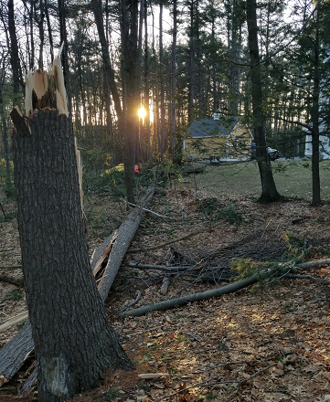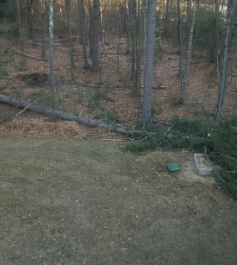 This fell during the high winds that were present on April 4, 2018. The tree landed on my children’s sandbox, fortunately they were inside at the time.
4 Pines selected for removal (100 ft within conservation area):
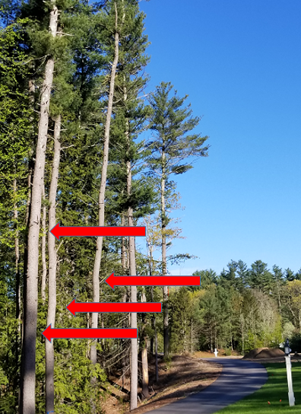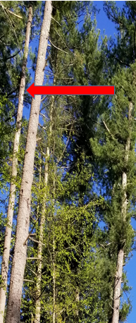
Rot exists on the smaller pine

These four trees pose a significant risk to my children when they play in our driveway. During the last winter snowstorm they were leaning more than 45 degrees due to the excessive weight of the snow.
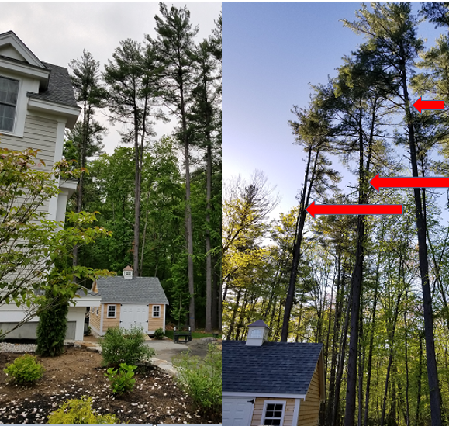

These three trees pose a direct risk to my house and our backyard where my children play. The limbs are split on 2 of the 3 pines and 1 of the 3 is leaning significantly towards my house.

Thank you in advance for your consideration. This is a matter of safety for my family. Please inform me, at your earliest convenience, the necessary steps to gain authorization for removal.

Thank you,

Matt Rainville
617-483-3371
rainvillemd@gmail.com

