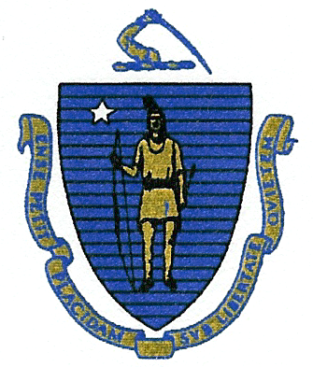
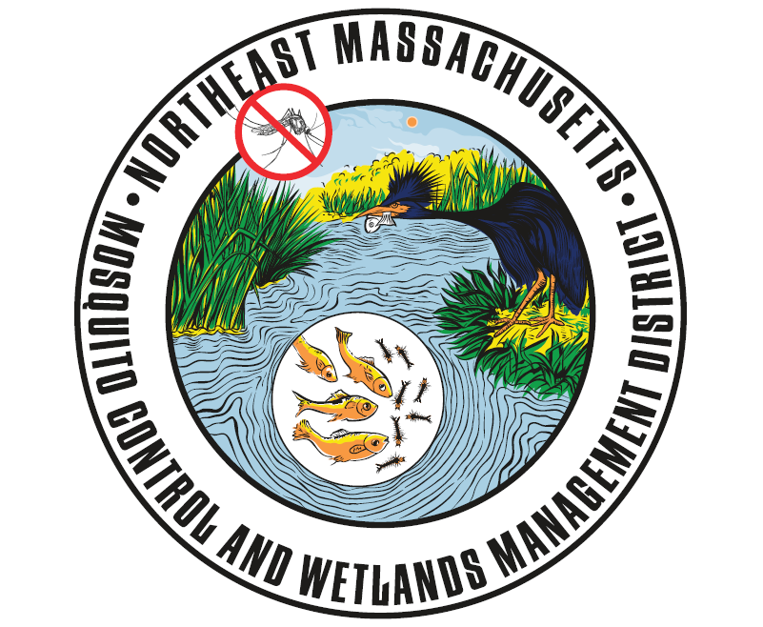
Commonwealth of Massachusetts
State Reclamation and Mosquito Control Board

Northeast Massachusetts Mosquito Control
and Wetlands Management District
118 Tenney Street
Georgetown, MA 01833
Phone: (978) 352-2800
www.nemassmosquito.org

Commissioners
Roy E. Melnick: Executive Director John W. Morris, CHO: Chair
William Mehaffey, Jr.: Operations Manager Vincent J. Russo, MD, MPH: Vice Chair
Emily D.W. Sullivan: Wetlands Project Coordinator Paul Sevigny, RS, CHO
Kimberly A. Foss.: Entomologist Joseph T. Giarrusso, Conservation Officer
Robyn A. Januszewski: Biologist Rosemary Decie, RS

DATE POSTED: June 19, 2018

PUBLIC MEETING NOTICE AND AGENDA

District Board of Commissioner’s Meeting
June 26, 2018
09:00 AM
118 Tenney Street, Georgetown, MA

As posted with the Commonwealth of Massachusetts Office of the Secretary of State, the Executive Office of Administration and Finance, the State Reclamation and Mosquito Control Board and all subscribing communities, there will be a meeting of the Northeast Massachusetts Mosquito Control and Wetlands Management District, Board of Commissioners on June 26, 2018, 09:00 AM.

Agenda as follows:

- Old business.
- New business.
- Public comments.
- Personnel Matter to be discussed in Executive Session pursuant to M.G.L. c. 30A, Section 21(a)(1) (vote for action).
- Adjourn.
Posted on Tuesday, June 19, 2018 at 2:13pm by Robin Phelan, Town Clerk

