MERRIMACK VALLEY PLANNING COMMISSION
160 Main Street
Haverhill, MA 01830

Monthly Meeting
Thursday – December 20, 2018

Time: 7:00 pm

AGENDA

1. Call to Order
2. Roll Call
3. Adoption of November Meeting Minutes
4. Warrant for November
5. Chairwoman’s Comments
6. Director’s Report
7. Contracts
8. Focus on Haverhill Presentation
9. “Commission on the Future of Transportation in the Commonwealth Update”
10. Local and Regional Issues
11. Other
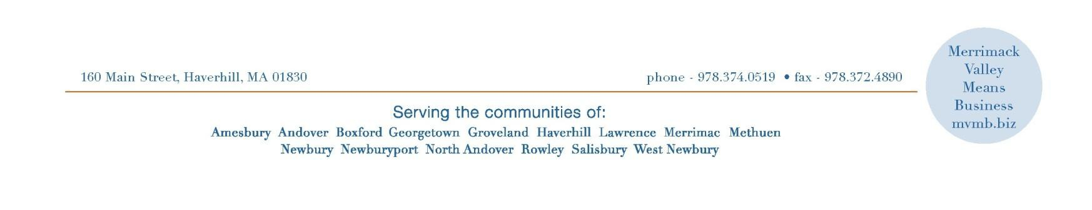
12. Adjourn
Posted on Wednesday, December 12, 2018 at 2:19pm by Robin Phelan, Town Clerk

