BOXFORD COURTS
Online Booking

BOOK A COURT

- On your phone, tablet, or computer, go to https://boxfordcourts.skedda.com/.
- Find an open date and time to play by adjusting the date at the top of the screen.
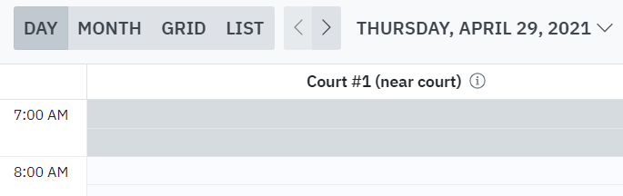
TIP Click MONTH to see open availability for a full week.
- Click a day/time slot and then click or click to create a booking.

Registration and login: If you have not previously registered a new account or you are not already logged in, you might be prompted to do so. In the NEW BOOKING window, enter your email address. Click Next. Follow the instructions provided.

- Complete your booking by entering the required details, including the date/time and court (called a space). For the booking title, enter your name.

- Click .

When you look at the calendar, your bookings will include your name. When other players hover over your bookings, your name is anonymous, as shown in this example:
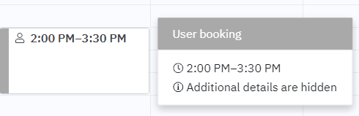

CANCEL A BOOKING

- Go to https://boxfordcourts.skedda.com/ and log in.
- Locate the booking that you want to cancel. Click the down arrow, select Cancel your booking, and then select Yes, do it.

